This diagram shows an overview of the task. There are two things for you to learn in order to do well on this task.

1. Which **step 1** box tends to take you to which set of **step 2** boxes
2. Which **step 2** boxes are most likely to deliver a reward (coin)

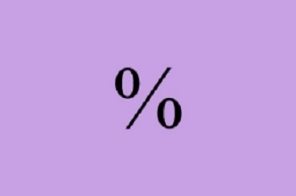

**Step 1**

At the start of each turn, you will be able to choose between two step 1 “start” boxes, each with their own unique symbol. One of the start boxes usually brings you to one set of the step 2 “decision” boxes, and the other start box usually brings you to the other set of decision boxes.

For example, one start box will bring you to one set of decision boxes on 7 out of 10 turns, but bring you to the wrong set of decision boxes on 3 out of 10 turns, by mistake. These chances are fixed, so you just need to learn these rules once.



**Step 2**

Following your step 1 choice, you will be presented with a set of decision boxes. Each decision box has its own unique symbol and its own likelihood of delivering a coin. Importantly, the chance of each box delivering a coin **will change** **slowly** throughout the task, and the likelihood that a box will deliver a coin is not related to the likelihood of the other boxes delivering a coin. It is your job to keep track of which decision boxes are currently better (more likely to deliver a coin) than others and to try to find these boxes.

There are no strange patterns to this task, such as a box delivering a coin on every other choice. The computer is not trying to play tricks on you; it strictly works on the chance assigned to each box, which will change slowly over time.



To sum up, you need to learn:

1. Which **step 1** box tends to take you to which set of **step 2** boxes (this *stays the same* throughout the task)
2. Which **step 2** boxes are currently good (most likely to deliver a coin, and this *changes* throughout the task)



During each step, you will use the **left** and **right arrows** to select a box. We will now go through 10 practice trials.